**U-nite**

U-nite is a website for university students in Philadelphia, Pennsylvania to sell and acquire items such as furniture and textbooks. Students, using their university email, will be able to browse and post listings for items they want to buy and sell, have access to Q&A homework sections and other forums, and be able to meet new people through a friends and messaging system.

**Figure 6-1 - System Boundary**

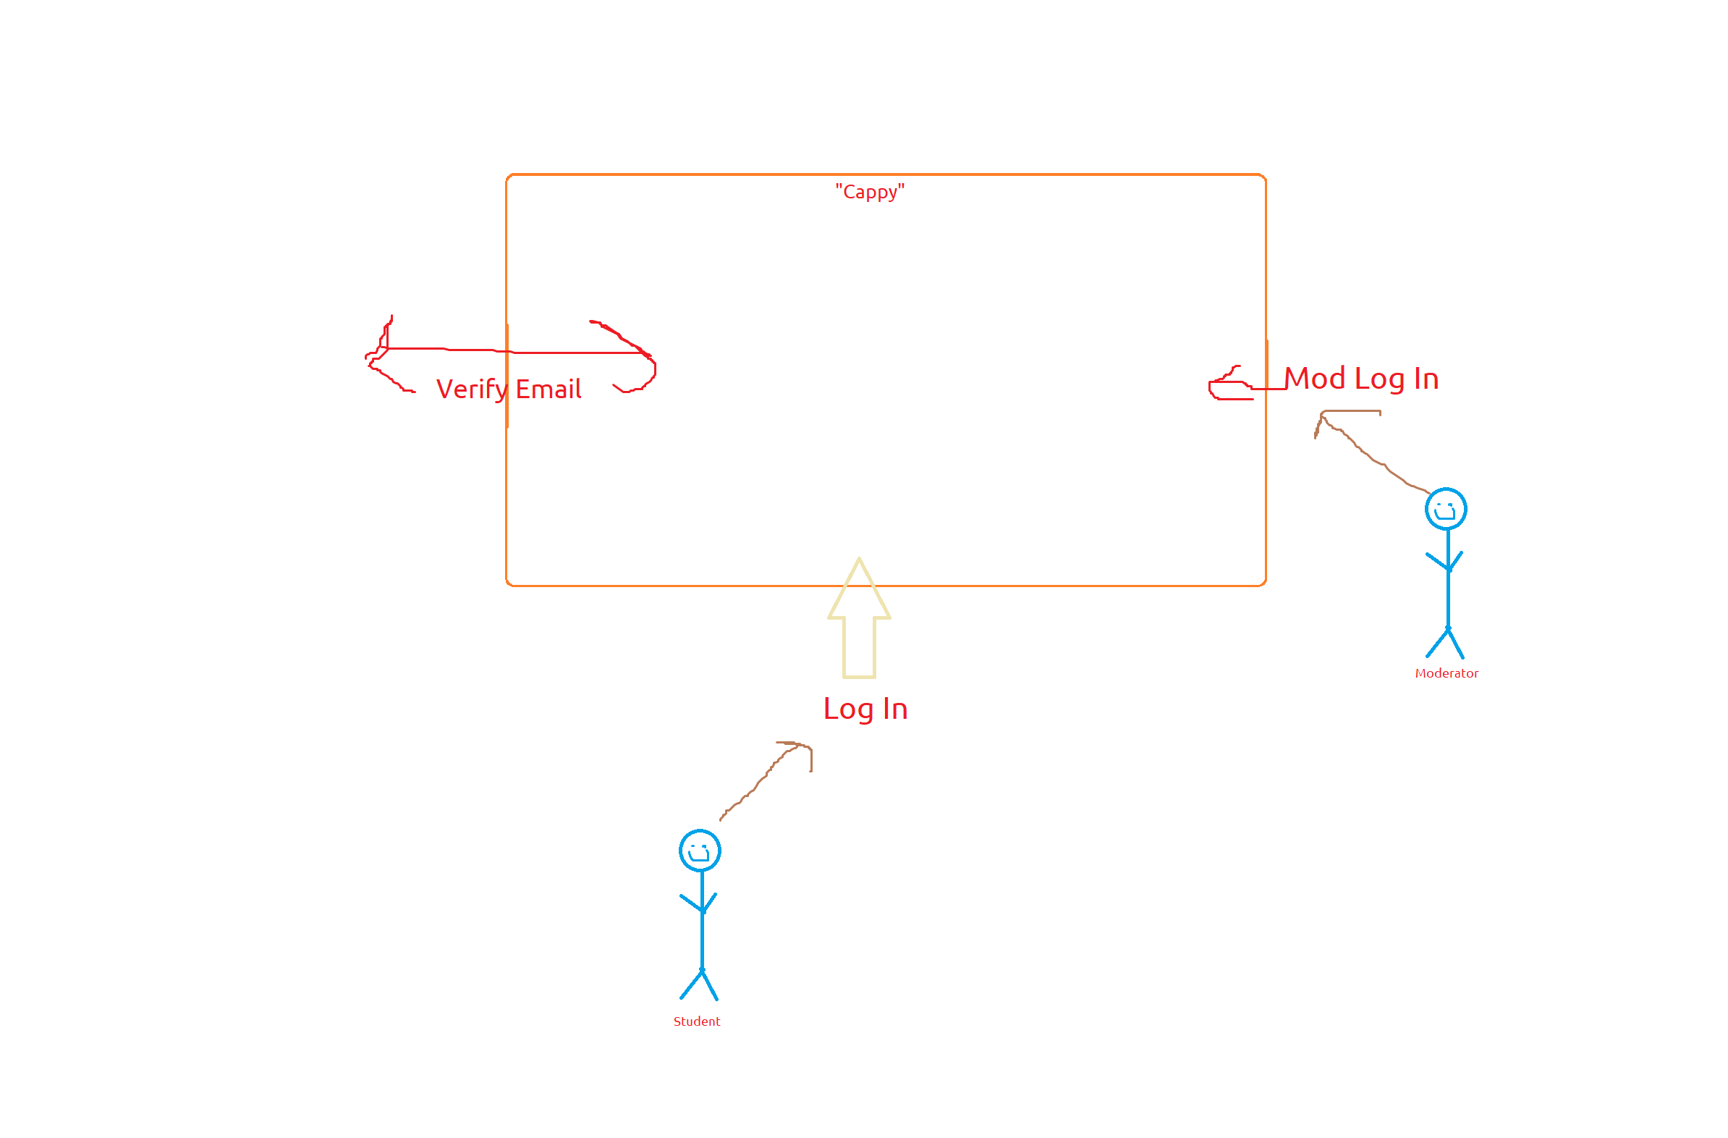

Figure 6-1 showcases the system boundaries for U-nite. There are three major interfaces for the system: a moderator log-in, a student log-in, and a university email verification for authentication of students.

**Figure 6-2 - Possible System Components**

1. Moderator Interface - web interface for moderators of various forums
2. Website - web interface for students
3. Access Manager - user university email authentication module
4. Discussion Application - interface for random discussions amongst users based on topic
5. Buy/Sell Application - interface to buy and sell items
6. Q&A Application - interface for the asking and answering of questions based on topic
7. User Manager - stores past messages, history, and user information
8. Database - information for posts, users, and messages
9. Messaging Application - interface for direct messaging between users

Figure 6-2 provides a primary list of system components. Components 1 and 2 are for the various user interfaces on the website, one for students and one for moderators, and includes the visual interface and the code for it. Components 3 through 6 relates to code for various aspects of the website’s main functions. Components 7 and 8 deals with data management for the website as a whole and for user information management. Component 9 is a currently out-of-scope component of the system.

**Figure 6-3 - System Overview Diagram**

Figure 6-3 shows the major components of the system, system interfaces, and the connections between components.

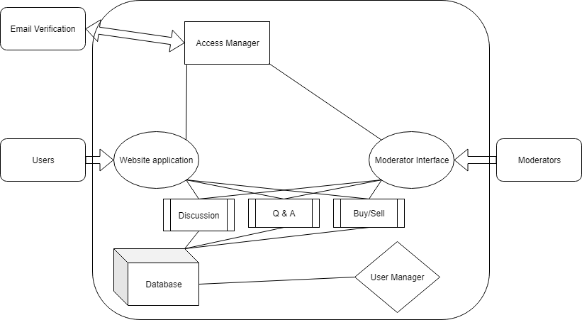

**Figure 6-4 - Screen Hierarchy Diagram**

Figure 6-4 shows the screen hierarchy for any given user.

